Specialized Database Items # 2 and #5

Learning Team ‘C’

DBM/384

August 28, 2016

Professor Dickens

ITEM #2 – Create an insert statement that will be used to initially add an inventory item. Remember that the previous data will be null, the start date will be today’s date, and the end date will be null.

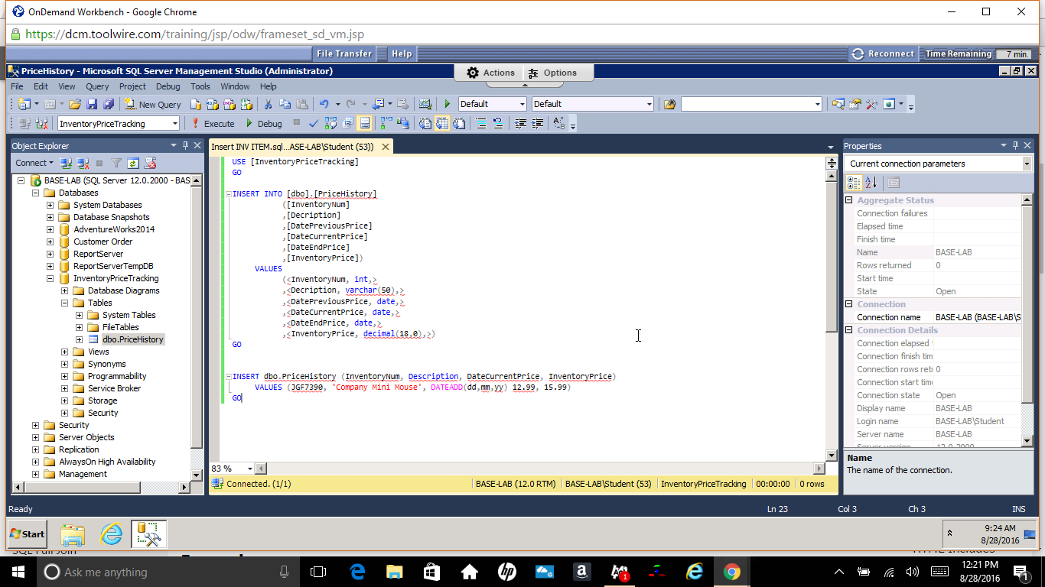

ITEM #5 – Create a query that will display a list of all the current inventory items.

